**Pradumn Kumar**

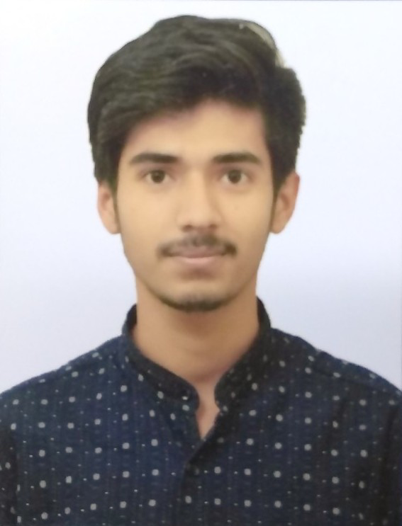

**Solution Integrator**

**Address**

U46/14, Near Phase-3 metro station,

DLF Phase-3, Gurgaon,

Haryana-122002 **Twitter** [twitter.com/PRADUMN30](https://twitter.com/PRADUMN30)

**Phone** 8967472730

**E-mail** pradumn30@gmail.com

**Date of Birth** 1995-01-04

* Certified UiPath Advanced RPA Developer.
* Active member of UiPath RPA Delhi NCR group.
* 2+ years of work experience at Ericsson India.
* Strong knowledge of RPA (UiPath), SQL, Programming logic.
* Knowledge of Shell scripting, Red Hat Linux, Java, Networking.
* Good Analytical skills.

**Experience**

|  |  |  |  |  |
| --- | --- | --- | --- | --- |
| **2019-03 - Present** | | **RPA Developer**  *Self-learner*  **UiPath**  After getting to know the capabilities of an RPA tool, I decided to start learning it on my own. Thanks to the free courses available on UiPath academy website and the community edition of their development software, I now am confident about my progress in this field. Looking forward to applying my knowledge in real life projects.  **Achievements**:   * + UiPath Advanced RPA Developer certified.   + Built a strong knowledge of UiPath tools, activities, and RE-Framework.   + Can develop RPA projects keeping project development standards and good practices in mind.   + Also have knowledge of UiPath Licensing and RPA Security aspects.   + Check out some RPA [sample projects](https://github.com/pradumn30/Public-Sample-Projects) developed by me.   + Also, you can check out my [sample Java project](https://github.com/pradumn30/test) which involves database to store data. | | |
| **2017-09 - Present** | | **Solution Integrator**  *Ericsson India Global Service Pvt. Limited.*  **BHARTI AIRTEL, VODAFONE IDEA, DST BRUNEI, INDOSAT**  The project handles many of the critical modules of these telecom operators. These are very important for uninterrupted operations and any issue in the services, can easily result in a lot of customer complaints. The job is to develop scripts to automate various tasks and to minimize the downtime by quickly resolving issues. Time constraint and project knowledge are critical for the project.  **Responsibility**:   * + Deployment of deliverables.   + Ensuring uninterrupted operation.   + Generating the requested data and reports.   **Achievements**:   * + Awarded as the Star performer for my work.   + I am the primary SPOC of this project. | | |
| **Education** | |  | | |
| **2013-06- 2017-06** | | **Sikkim Manipal Institute of Technology**  B.Tech. in Electronics and Communication Engineering with 89.8% of marks. | | |
| **2011-05- 2013-03** | | **Adwaita Mission High School**  HSC in Science from CBSE with 64.4% of marks. | | |
| **2011-03**  **Skills** | | **Saint Joseph's School**  SSC from ICSE with 78.57% of marks. | | |
|  | | RPA (UiPath) | |  |
|  | | SQL | |  |
|  | | Red Hat Linux | |  |
|  | | Networking Fundamentals | |  |
|  | | Core Java | |  |
|  | | VB.Net | |  |

**Languages**

|  |  |  |
| --- | --- | --- |
|  | English |  |
|  | Hindi |  |